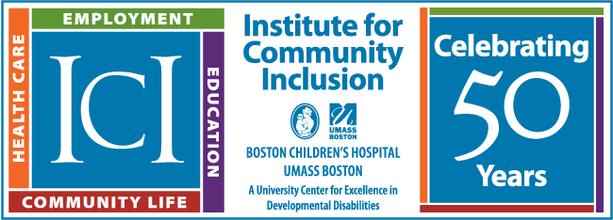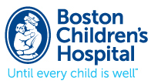
LEND Program Seeks Self-Advocate for 9 Month Fellowship:
The LEND Program is seeking a self-advocate, someone with lived experience of disability, to take part in the LEND fellowship that runs from September 2023– May 2024. The selected individual will receive a small stipend. You can apply if you.
- live in Massachusetts
- have developmental or other disabilities
- are not in school
- are not in a transition program
LEND stands for Leadership Education in Neurodevelopmental Disabilities.
The LEND Program is a joint initiative of Boston Children's Hospital and the ICI. The program provides interdisciplinary training for a diverse group of fellows from disciplines including social work, psychology, developmental medicine, audiology, occupational therapy, nursing, public health, genetic counseling, child development, education and law. Participants include parents of children with disabilities, and self-advocates (people with disabilities who are finding ways to increase their independence and speak up for their goals). Self-advocates often bring a support person with them to the program.
If selected, you will be required to attend classes at Boston Children’s Hospital on Fridays, 8:00 am to 4:00 pm. You can devote four hours per week for clinic observation, community visits, and community work. You will need some weekday time for clinic observations. Otherwise, some of this can be done during evenings and/or weekends.
Highlights:
- Seminars on leadership, evidence-based practice, interdisciplinary collaboration, cultural awareness, public health, conflict resolution, research, policy, clinical issues, and advocacy
- Participation in policy/advocacy conference with training in legislative issues and a chance to visit Capitol Hill.
- Opportunity to work with community-based organizations serving diverse populations and/or children and families with special health care needs
- In-home visits with a family with a child with a developmental disability
- Meetings with Title V programs
- Observation of some hospital clinical teams
For more information, or to apply, please contact: Angela.Lombardo@childrens.harvard.edu

Learn more about the LEND Program at www.LENDBoston.org

